DIS- Moche, 500-800AD

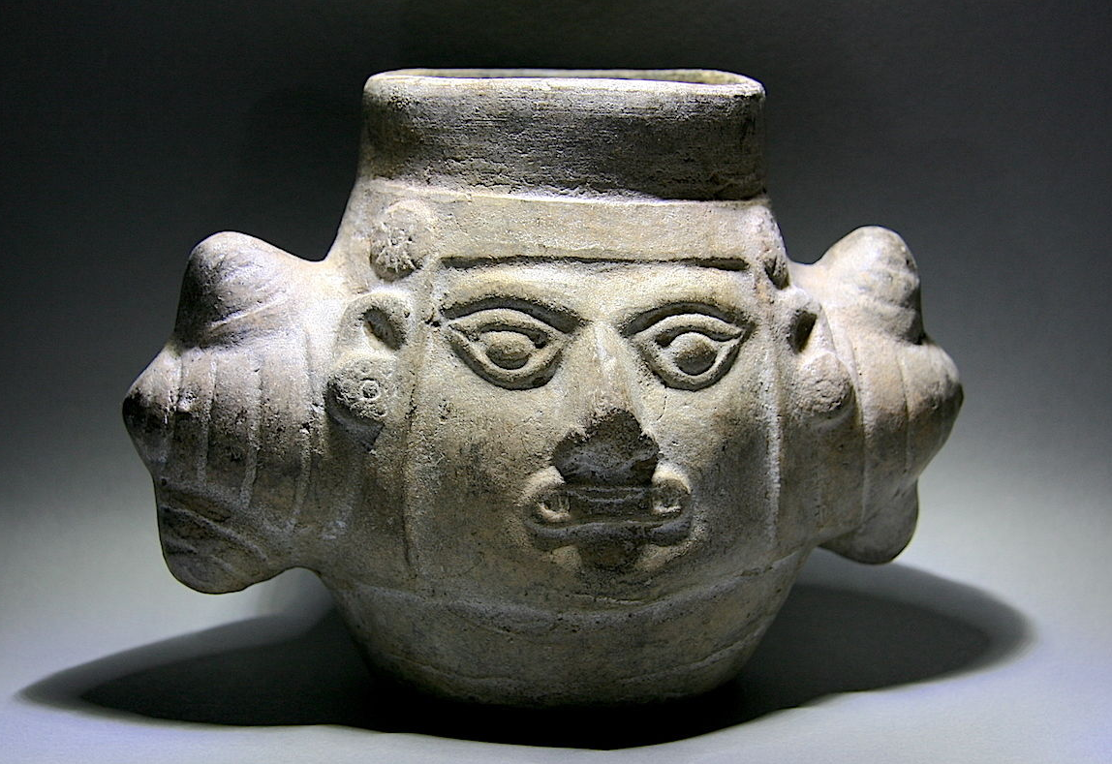 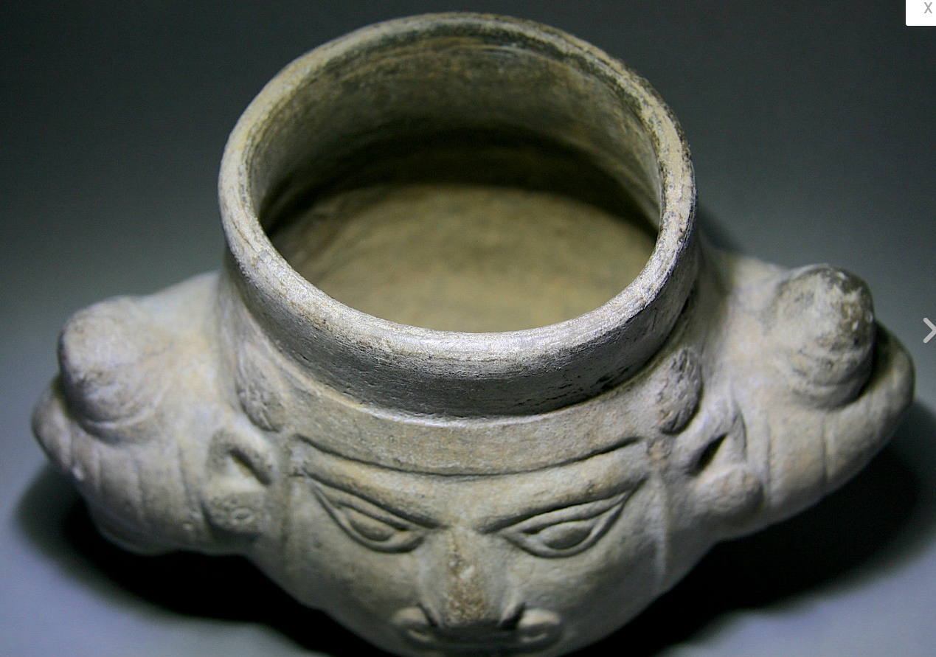 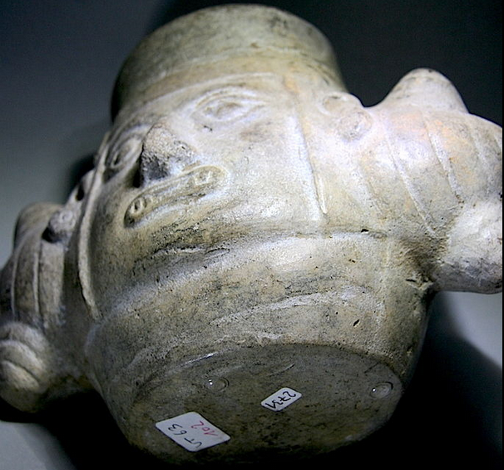 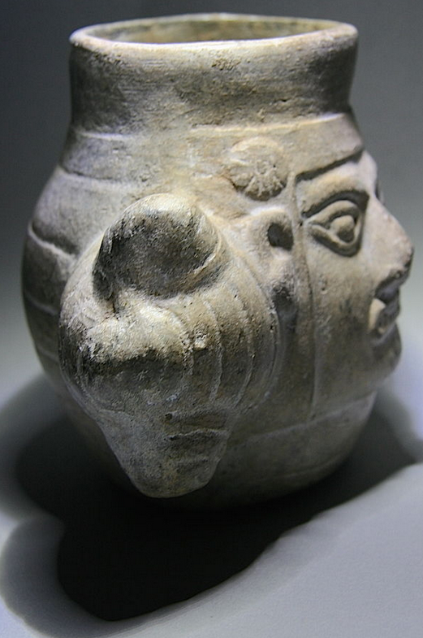 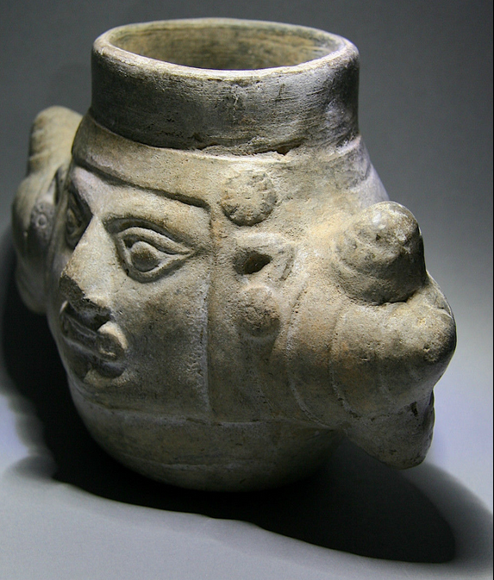 Very interesting portrait face head warrior mug with wonderful details; the eyes are wide and are under the influence of drugs, in the mouth, he holds a predator bite of Ai Apaec. Ai Apaec, the chief god of the Moche, probably only the best warriors were their chief god set equal. He is wearing a helmet with two war clubs heads and ear pegs made of shells, and a headband with shells. Cracks on nose and small cracks around, and age-related surfaces, as well as small scratches and patina, otherwise fine. So a head belongs in every collection, a wonderful and great piece!

See the price inclusive the lab test, unbeatable!

**Culture: Moche, 500-800AD**

**Age: 1200 years old, TL tested, new Test Document 2014 inclusive!**

**Tall approx.: 6” ; Wide: 8”**

**Important for collectors who do not know my offers:** it gives antiques, where you don't know, it is genuine or new (looks old or is a fake...). Many looks old, but it is? The best way to find out is an independent laboratory substance test. For many collectors is one reason, why they don't make a test, the high price. (**In Europe are the cost today ca. 260 Euro / 280USD per test!**) Here you get an antique piece inclusive a test (Thermo luminescence Analysis Report). For me as seller is this best feeling, because I can give you a really accurately described piece and the guarantee, made in antique times, an antique artisan, from an old long ago bygone culture!

**Provenance: Collection Gottfried Eysank 1970, Private collection 2014.**